**Autonomous vehicles**

**What does it do?**

Autonomous vehicles can drive themselves “from a starting point to a predetermined destination in autopilot mode, using various in-vehicle technologies and sensors, including adaptive cruise control, active steering, anti-lock braking systems, GPS navigation technology, lasers and radar” (Gartner, 2012).

The Society of Automotive Engineers (SAE) has defined 6 levels of driving automation (Synopsys, 2019). The following graphic describes them:

Levels 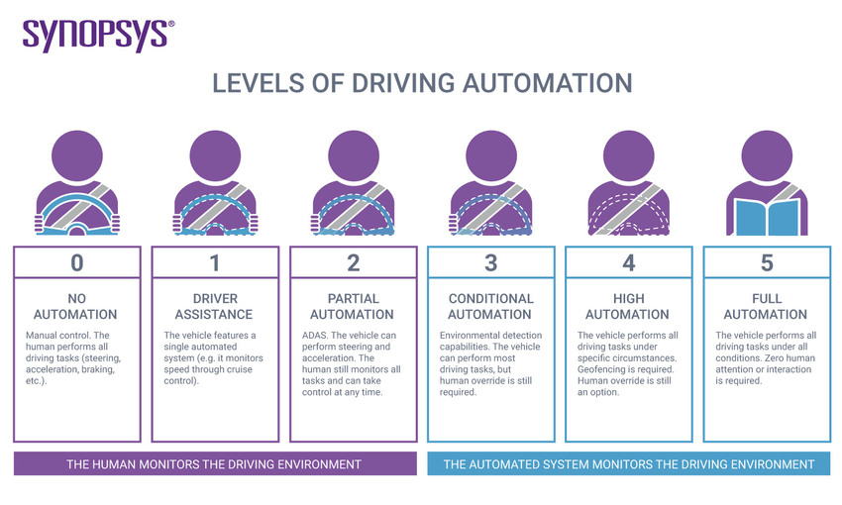

Figure 1: Levels of Driving Automation (Synopsis, 2019)

Within the first three levels, the human monitors the driving environment. Within the next three the automated system monitors the driving environment with different levels of automation, from conditional to full.

There’s an important distinction to be made here, as a preface to the following information – there is a difference between automated versus autonomous, at least as defined by the SAE. The Society prefers the use of automated in this particular context, as the word autonomous implies the vehicle would be self-aware, and capable of making its own choices.

Encapsulating current capabilities, the sensors of an autonomous vehicle gather real-time data of the environment as well as coordinates, car velocity and acceleration (vectors) and potential obstacles. They make use of a GPS, geographic navigation system to gather information about location (GIS) as well as an inertial navigation system (INS) to calculate relative vehicle location. Electronic maps (EM) store information about traffic and road facilities, currently available for vehicles at level 2 and 3 automation. Advanced Driver Assistance Systems (ADAR), which use laser, visual and radar perception, are available in vehicles with level 3-4 autonomy, and require about 12 to 24 Gbps of network bandwidth. Lastly, Vehicular Ad-Hoc Networks (VANETs), spontaneous networks of vehicles, are able to communicate with each other utilizing these formed networks (Singh and Saini, 2021).

Further exploring ADAS, the role of these systems “is to prevent deaths and injuries by reducing the number of car accidents and the serious impact of those that cannot be avoided” (www.synopsys.com, n.d.). Essential ADAS applications include pedestrian detection and avoidance, lane departure warning and correction, traffic sign recognition, automatic emergency breaking and blind-spot detection. The systems are incorporated into chips called SoCs (systems on a chip) (Synopsys, n.d.).

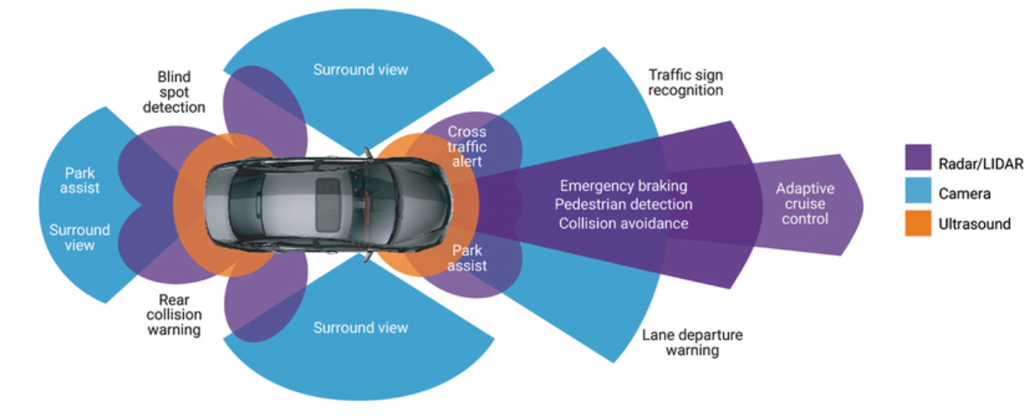

Figure 2: Application of ADAS systems (Synopsys, n.d.)

There are two types of communication technologies in VANET architecture – vehicle to vehicle, and vehicle to infrastructure communication (Mahmood et al., 2021). Vehicles are able to communicate traffic-related information within the range of the network. When an accident occurs the contact vehicle sends alerts to other nodes accessing the network, telling them to avoid the area.

There currently seem to be security issues in the use of VANET architecture, and most of these are in the realm of security. A few examples are malware attacks where a virus can infiltrate the vehicular system, denial of service attacks where communication between a vehicle and its network can be disrupted, and spamming attacks which may bring about involuntary system crashes (Sharma, Sharma and Tomar, 2019). These are problems typical of any system embedded in a network.

Here is another look at the levels of driving automation, broken down by functionality:

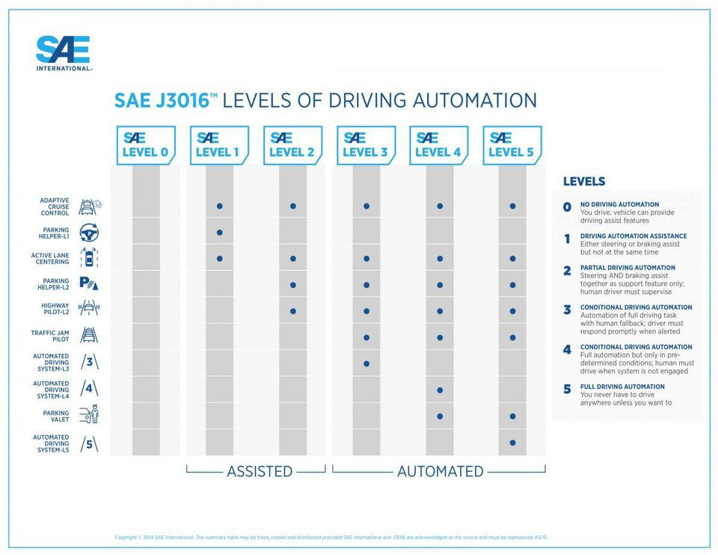

Figure 3: Levels of Driving Automation by Functionality (Sachdev, n.d.)

The highest level of automation available at present is a level three vehicle. “Level 2 vehicles are the current sweet spot for many automakers” (Sachdev, n.d.). This observation includes the famed Tesla vehicles. There are currently no level 4 vehicles available on the market. Elon Musk has stated that there may be a beta test of a level 4 Tesla soon, although no specific dates are mentioned (Cooley, n.d.). The Hyundai Nexo was touted as the first level 4 vehicle during its development (Green Car Congress, n.d.), but current reviews do not mention any aspect of automation functionality – see Drive (2021) for an example.

What about the near future? The key premise, and one of the main drivers of the autonomous vehicle market has been the provision of safe travel. An extremely high proportion – 9 out of 10 crashes in fact – have been found to have occurred as a result of human error (Kadry, 2021).

Before this statistic can be changed in a meaningful way, however, automated systems will have to be able to perceive the road and associated environment better than the best human driver. Data is important here; in the future autonomous cars will generate 300TB of data per year per vehicle. This is an astounding amount of data per trip, considering our vehicles are parked 95% of the time on average (Streetsblog USA, 2016), and 645 GB of data generated per hour. 5G technologies that will permit the use of Artificial Intelligence will also be very important in the development of vehicle automation and increased safety (Cubic, 2021).

**What is the likely impact?**

Fundamentally, the wide adoption of autonomous vehicles would mean fewer accidents. This would mean less injuries and fatalities, and lower costs for users and insurance companies. The amount of time the users of autonomous vehicles have available would increase – as the “driver”, at least in a vehicle with a high autonomous level, would not have to be in control, and their time while in a vehicle could be spent more productively (Klaver, n.d.).

What about the impact on jobs? The most obvious change would occur in the transportation sector. As the sector adopts autonomous vehicles, whether for transporting goods or the public, many drivers would lose their jobs. In the US, the total loss of income would amount to approximately 180 billion per year. Employment in service and repair centers would also be affected, as the lower number of vehicle crashes would cause loss of income for occupations in this sector (Klaver, n.d.). As at any time in the past, as advancements in technology become widely adopted, workers involved with occupations affected by the technological change may be forced to reskill, and experience loss of income for some time.

There is a huge upside to the adoption of autonomous vehicles. The new tech will be able to cut emissions by improving vehicles’ braking and acceleration, eventually reducing emissions by 90% (Klaver, n.d.).

**How will this affect you?**

I do not think I will be directly affected in an economic sense; I do not have employment that is directly or even indirectly related to any technological changes in this sector. Neither do any members of my family. From a social, societal perspective, I believe everyone will be affected – it will take some time for these new technologies to be widely accepted, to the extent that we will be comfortable being inside a vehicle the motion of which is not being controlled by a human operator. We will need to find ways of occupying ourselves during this time; the obvious benefits of completing work-related activity cannot be understated but being able to spend time on social activities with family and friends will become quite common. This probably seems strange to most of us right now but will most likely become commonplace in the near future. I am looking forward to it.

**References**

Cooley, B. (n.d.). *Driver Assistance Advancements in 2022*. [online] Roadshow. Available at: <https://www.cnet.com/roadshow/news/the-most-important-self-driving-cars-of-2022/>.

Cubic. (2021). *Planning for Tomorrow’s Mobility with 5G and Cellular Vehicle-to-Everything (C-V2X)*. [online] Available at: https://www.cubictelecom.com/blog/c-v2x-cellular-vehicle-to-everything-5g/ [Accessed 15 Apr. 2022].

Drive. (2021). *2021 Hyundai Nexo review*. [online] Available at: https://www.drive.com.au/reviews/2021-hyundai-nexo-review/ [Accessed 15 Apr. 2022].

Gartner (2012). *Autonomous Vehicles*. [online] Gartner. Available at: <https://www.gartner.com/en/information-technology/glossary/autonomous-vehicles>.

Green Car Congress. (n.d.). *Hyundai NEXO fuel-cell vehicles self-drive (Level 4) 118 miles from Seoul to Pyeongchang*. [online] Available at: https://www.greencarcongress.com/2018/02/20180204-nexo.html [Accessed 15 Apr. 2022].

Kadry, M. (2021). *Road to 2030: the Future of Autonomous Vehicles*. [online] Cubic. Available at: <https://www.cubictelecom.com/blog/self-driving-cars-future-of-autonomous-vehicles-automotive-vehicles-2030/>.

Klaver, F. (n.d.). *The economic and social impacts of fully autonomous vehicles*. [online] Compact. Available at: <https://www.compact.nl/en/articles/the-economic-and-social-impacts-of-fully-autonomous-vehicles/>.

Mahmood, J., Duan, Z., Yang, Y., Wang, Q., Nebhen, J. and Bhutta, M.N.M. (2021). Security in Vehicular Ad Hoc Networks: Challenges and Countermeasures. *Security and Communication Networks*, [online] 2021, p.e9997771. Available at: <https://www.hindawi.com/journals/scn/2021/9997771/>.

Sachdev, M. (n.d.). *Explanation of the 6 Levels of Driving Automation*. [online] blog.rgbsi.com. Available at: <https://blog.rgbsi.com/6-levels-of-driving-automation>.

Sharma, B., Sharma, M.S.P. and Tomar, R.S. (2019). *A Survey: Issues and Challenges of Vehicular Ad Hoc Networks (VANETs)*. [online] papers.ssrn.com. Available at: https://papers.ssrn.com/sol3/papers.cfm?abstract_id=3363555 [Accessed 14 Apr. 2022].

Singh, S. and Saini, B.S. (2021). Autonomous cars: Recent developments, challenges, and possible solutions. *IOP Conference Series: Materials Science and Engineering*, 1022, p.012028.

‌ Streetsblog USA. (2016). *It’s True: The Typical Car Is Parked 95 Percent of the Time*. [online] Available at: <https://usa.streetsblog.org/2016/03/10/its-true-the-typical-car-is-parked-95-percent-of-the-time/>.

Synopsys (2019). *What is an Autonomous Car? – How Self-Driving Cars Work | Synopsys*. [online] Synopsys.com. Available at: <https://www.synopsys.com/automotive/what-is-autonomous-car.html>.

‌Synopsis (n.d.). *What is ADAS (Advanced Driver Assistance Systems)? – Overview of ADAS Applications | Synopsys*. [online] Available at: <https://www.synopsys.com/automotive/what-is-adas.html>.

‌

‌

‌